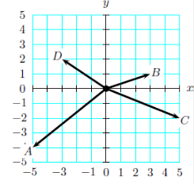
- In the space provided below, show the vector addition of vector A+B.
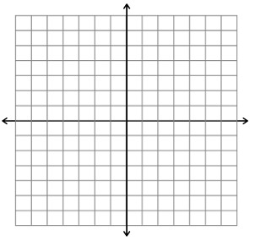
- Assume that vector C is an initial velocity vector and vector D is a final velocity vector. Draw the acceleration vector. Only the magnitude and direction of the acceleration vector will be evaluated.
- A small plane is 100 km due east of Denver. After 1 hour of traveling in the same direction at a constant speed, it is 200 km due north of Denver. What’s the plane’s velocity? Include a magnitude and a direction in degrees due north of west.

