AP PHYSICS 1 Test Review

I. Basics

A. Unit conversion

(Be able to convert between metric quantities or between customary and metric given the appropriate relationships)

B. Know which units are used for acceleration, velocity, speed, displacement, distance, and time; be able to identify them.

C. Know the difference between a vector and a scalar; know which quantities listed in B above belong to which category.

II. Motion Graphs

1. Be able to interpret Velocity-time & Position-Time Graphs.
2. If given an Acceleration-Time graph what information could be gleaned from it?

Practice:

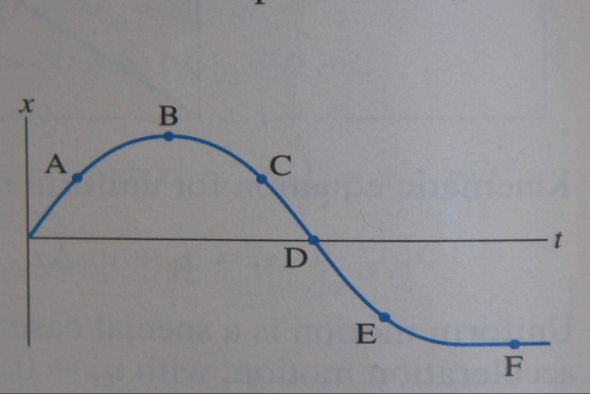

1. For the position time graph above, when is the object..
2. Moving the fastest
3. Speeding up
4. Slowing down
5. Turning around
6. Moving to the left

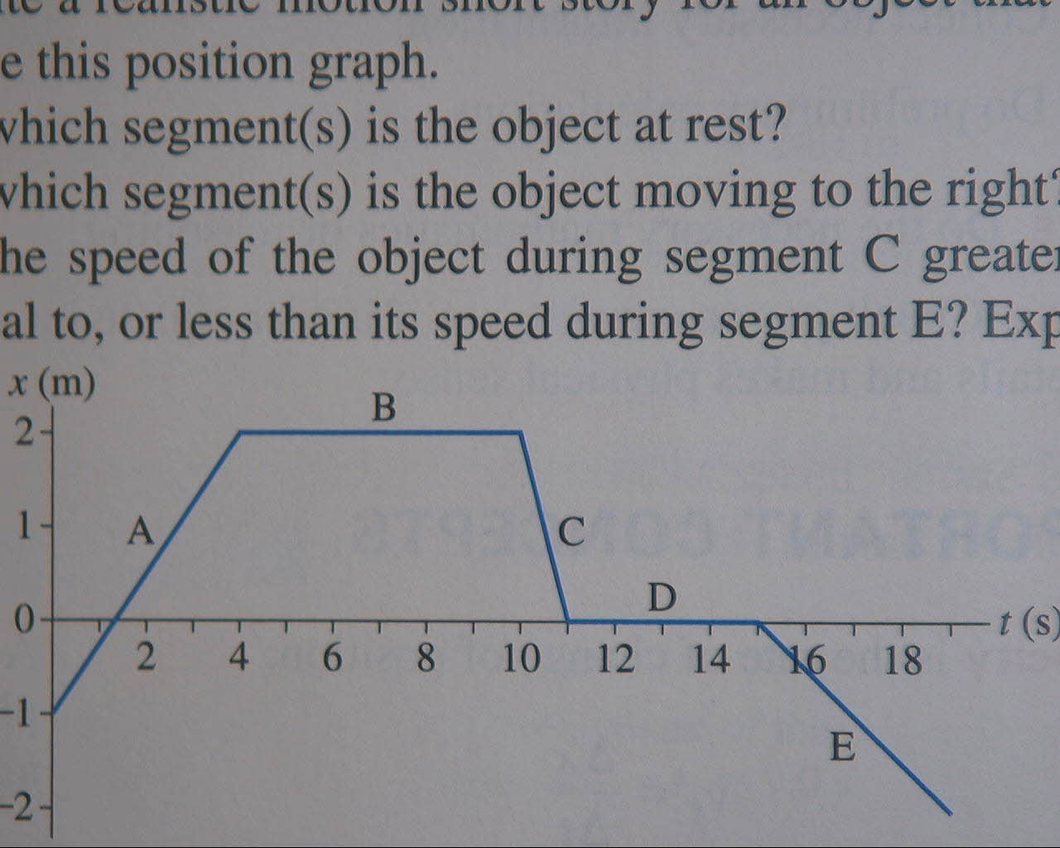

1. For the graph above
2. Where is the object at rest?
3. Calculate the velocity during C.
4. Sketch the corresponding velocity-Time graph…. using an appropriate scale.

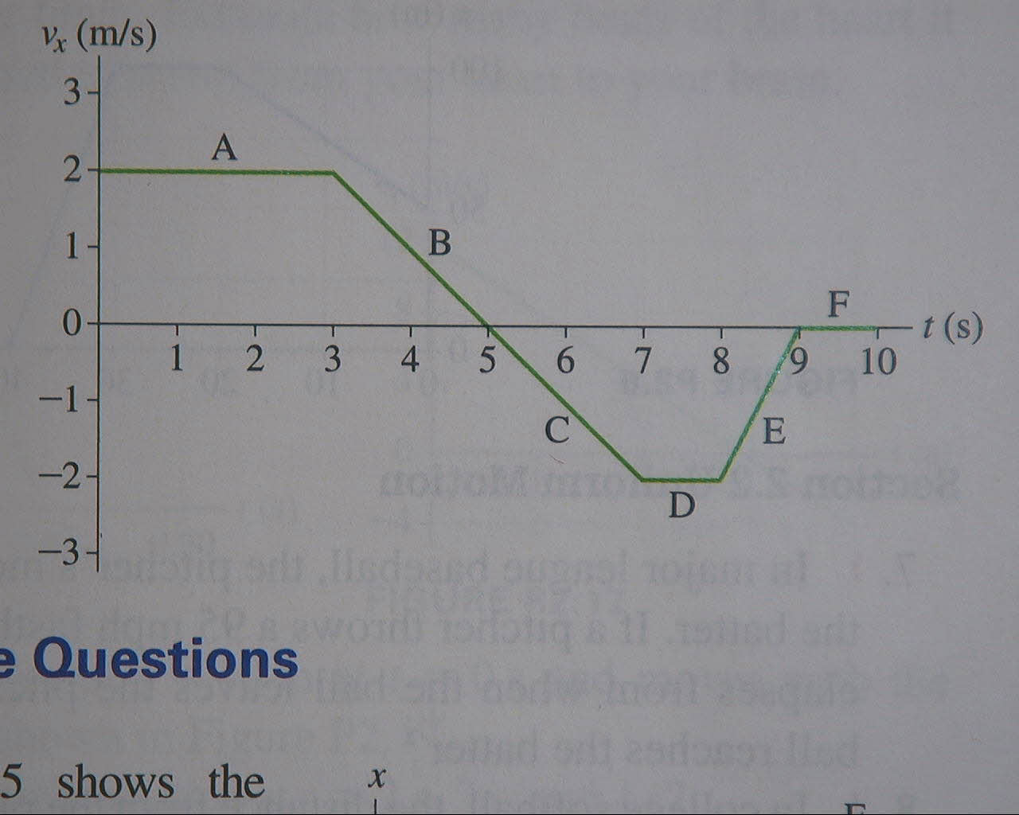

1. For the above velocity time graph…
2. Find the total displacement from 0 to 9seconds
3. Find the total distance traveled.
4. Find the greatest magnitude of acceleration.
5. Where does the object change directions
6. When is the object moving to the left?
7. Attempt to sketch the position-time graph that would correspond if the object’s starting position was at 0m.
8. Draw a position-time graph for an object that starts 3m to the left of the origin then moves at a constant speed 4m to the right in 3 seconds, stops for two seconds, then moves 5 meters to the left with increasing speed over a period of 4 seconds.
9. Draw a velocity time graph that shows and object traveling at 4m/s to the left for 3 seconds, then accelerates at +1m/s/s for 5 seconds, then travels at constant speed for 3 more seconds.

III. Lab questions

1. If two photogates are placed 0.30m apart on a ramp and the A time is 0.0309s and the B time is 0.010s… find the following. (The portion of the car that trips the photogate is 1.5cm in width.
2. The velocity at the A gate
3. The velocity at the B gate
4. The average velocity
5. The acceleration.
6. Sketch what a v-t graph would look like.
7. Sketch what a position-time graph would look like.

Free Fall/Kinematics

I. Basics

A. If wind resistance is ignored what is the acceleration of an object in free fall near the Earth’s surface?

B. What is the direction of the acceleration of an object that was dropped? An object that is moving upwards after having been launched? An object that is moving downwards after having been thrown down?

II. Problem Solving

SHOW COMPLETE WORK

Sketch a diagram that represents the problem

Identify the givens using the correct symbols from the equations

Identify the unknown using the correct symbol

Write the correct SYMBOLIC equation down.

Substitute known values

Solve for the answer WITH CORRECT UNITS

Problems to practice

(Those from quest are fair game…. Be able to solve those that have two different objects and require a system of equations)





