- A small plane travels at a steady 245 m/s in still air. It travels directly south across an unaccounted easterly wind that has a constant velocity of 60 m/s.
  - Draw the velocity vectors representing the plane’s velocity, the wind’s velocity, and the resultant velocity of the plane relative to the ground.
  - Based on the vector diagram in part A, determine the magnitude and direction of resultant velocity of the plane.
  - After 30 minutes of travel, how far off to the east is the plane diverted from its intended course?
- A train leaves a station. A man on the train is walking left at 0.5 m/s relative to the train that is traveling to the right at 10 m/s. A bird overhead is traveling over head to the left at 2 m/s. An observer sits on a bench and watches the train from the station.
  - What is the train’s velocity relative to the observer?
  - What is the observer’s velocity relative to the train?
  - What is the man’s velocity in relation to the observer?
  - What is the observer’s velocity relative to the man?
  - What is the bird’s velocity relative to the man?
  - What is the man’s velocity relative to the bird?
  - try other combinations for funzies
- A block slides down a frictionless ramp from rest inclined at an angle of 35 degrees from the horizontal. Determine the displacement of the block if it slides for 2.5 seconds down the ramp.
- Draw the vector addition of
  - Vector B and Vector D
  - Vector D and negative Vector A
  - Vector C and negative Vector 2B
  - Vector 0.5A and negative Vector D
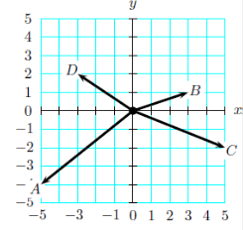
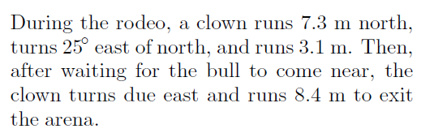

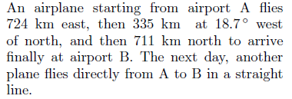
Determine the magnitude and direction of the displacement vector of the clown.

6.

Determine the magnitude and direction of the displacement of the plane.

