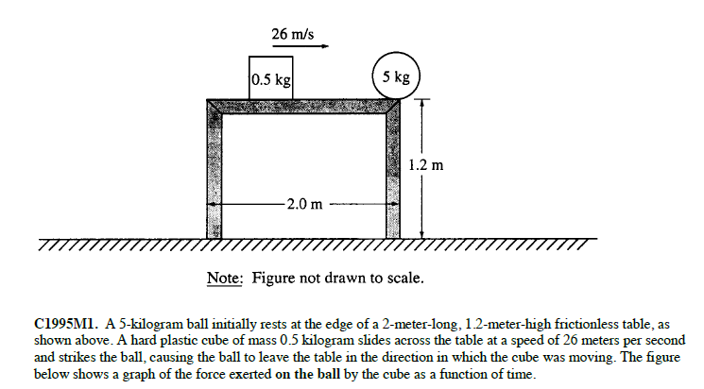
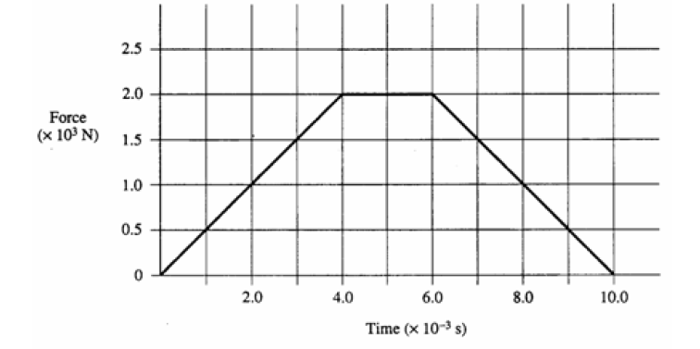
A. Calculate the initial momentum of both objects.
B. Calculate the impulse delivered to both objects over the time period shown in the graph.
C. Calculate the final momentum of both objects.
D. Calculate the final velocity of both objects.
E. Calculate the magnitude of the average force exerted on both objects for the time period shown on the graph.
F. What is the direction of the average force on both objects? Justify your answer.

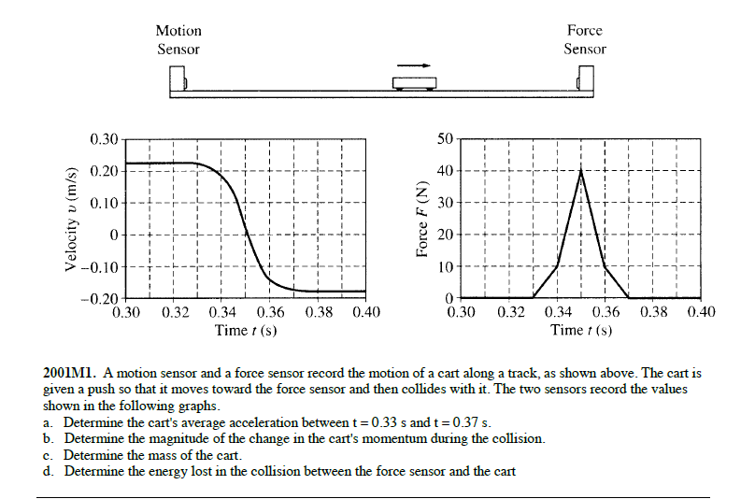
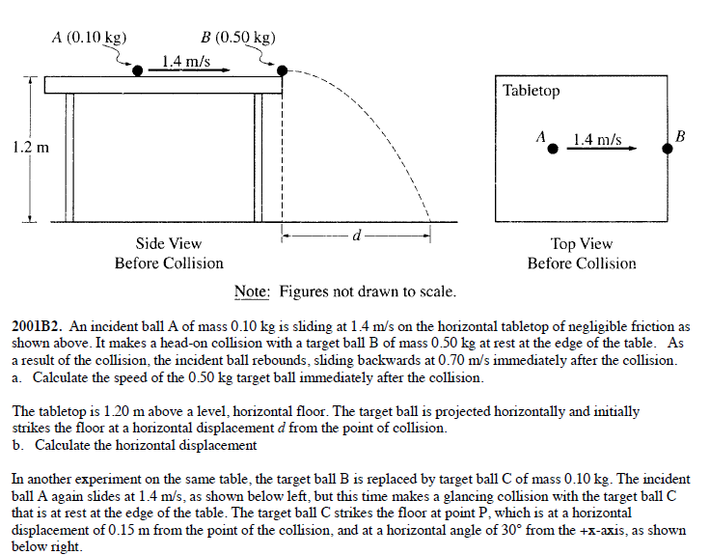
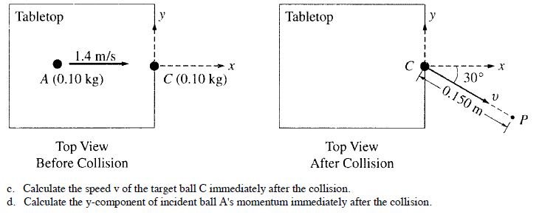

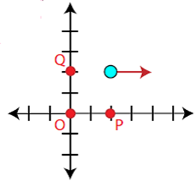
From the Power point notes….
Find the magnitude of the angular momentum for a 5 kg point particle located at (2,2) with a velocity of 2 m/s to the right…

A) about the origin (point O)
B) about point P at (2,0)
C) about point Q at (0,2)

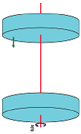
A disc with moment of inertia 1 kg·m² spins about an axle through its center of mass with angular velocity 10 rad/s. An identical disc which is not rotating is slid along the axle until it makes contact with the first disc. If the two discs stick together, what is their combined angular velocity?

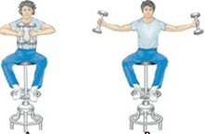
A person spinning in a chair at 1 rad/s pulls their arms in close to their body reducing their moment of inertia to ¼ of its original value. What is the person’s final angular speed?

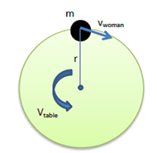
A 65.0 kg woman stands at the rim of a horizontal turntable that has a moment of inertia of 400 kg ∙ m² and a radius of 3.00 m.
The turntable is initially at rest and is free to rotate about a frictionless, vertical axle through its center. The woman then starts walking around the rim clockwise (as viewed from above the system) at a constant speed of 2.0 m/s relative to the Earth.
In what direction and with what angular speed does the turntable rotate?

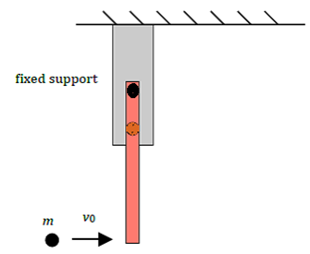
A 50 cm, 1kg rod hanging in a vertical position is struck head-on in an inelastic collision at the lower end by a ball of mass m = 0.500 kg sliding in a horizontal direction on a frictionless surface at velocity v₀ = 2.00 m/s as shown.
Determine the angular velocity, both magnitude and direction, of the ball-rod just after the collision.
For ease of calculation assume that the rod was pivoted about its end such that its moment of inertia can be calculated by I = 1/3 mL²

Suppose an empty "merry-go-round" having a radius of 1.8 m and a mass of 50 kg (I = ½mr²) is initially rotating on a frictionless axis counterclockwise at 15 rev/min.

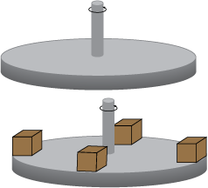

Simultaneously, four students walk up and place four 5-kg boxes (I = mr²) symmetrically along its outer edge so that each box's center of mass is located 1.50 m from the axis of the merry-go-round. What will become the merry-go-round's new angular velocity at the instant the boxes are in place?

Suppose a penny is resting on the top of a turntable that is rotating at 45 rev/min = 4.71 rad/sec. The radius of the turntable is 20 cm. The mass of the penny is 3.3 grams.
If the penny’s angular speed decreases to 2.71 rad/s over a 4 second time period, find the change in angular momentum of the penny then calculate the average torque acting on the penny. The penny’s distance from the axis of rotation is 10cm.

